**DEPARTMENT OF ELECTRONICS & COMMUNICATION ENGINEERING**

MANIPAL UNIVERSITY JAIPUR, JAIPUR – 303007 (RAJASTHAN), INDIA

JAIPUR

Date: 7th June, 2019

**CERTIFICATE**

This is to certify that the project titled **LUNG CANCER DETECTION** is a record of the bonafide work done by **Nutakki Serath Chandra** (159108080) submitted in partial fulfilment of the requirements for the award of the Degree of Bachelor of Technology (B.Tech) in **Electronics and Communication Engineering (ECE)** of Manipal University Jaipur, during the academic year 2018-19.

**Mr. Khamesh Kumar**

*Internal Guide, Dept of Electronics & Communication Engineering*

*Manipal University Jaipur*

**Dr. Manish Tiwari**

*HOD, Dept of Electronics & Communication Engineering*

*Manipal University Jaipur*

Hyderabad

Date: 17th May, 2019

**CERTIFICATE**

This is to certify that the project entitled **LUNG CANCER DETECTION** was carried out by **VINEETH APPALA** (159108149) at **NURONICS LABS PVT. LTD., HYDERABAD** under my guidance during **JAN 2019** to **MAY** **2019**.

**Mythilisharan Pala (PhD)**

Software Architect

Nuronics Labs Pvt. Ltd., Hyderabad

**ACKNOWLEDGMENTS**

I am grateful to Mr. A V Ramana, head of Nuronics Labs Pvt. Ltd. for hiring me as an intern and giving me a wonderful project to work on.

I am thankful to Mr. Mythilisharan Pala (PhD), my external guide, for the given opportunity to work under him as an intern. I also thank him for his guidance and support throughout the project.

I would like to thank Nikhil, my colleague, who supported and helped me in trouble during the project.

I would also like to extend my gratitude towards my project guide Mr. Khamesh Kumar, the project Head Dr. Tarun Kumar Dubey and the Department of Electronics and Communication Engineering of Manipal University Jaipur for their encouragement which helped me in completion of this project.

**Nutakki Serath Chandra**

**159108080**

**ABSTRACT**

Lung cancer is one of the dangerous and life taking disease in the world. However, early diagnosis and treatment can save life. Although, CT scan imaging is best imaging technique in medical field, it is difficult for doctors to interpret and identify the cancer from CT scan images. Therefore, computer aided diagnosis can be helpful for doctors to identify the cancerous cells accurately. Many computer aided techniques using image processing and machine learning has been researched and implemented. It is difficult to detect because it arises and shows symptoms in final stage. However, mortality rate and probability can be reduced by early detection and treatment of the disease. Best imaging technique CT imaging are reliable for lung cancer diagnosis because it can disclose every suspected and unsuspected lung cancer nodules. However, variance of intensity in CT scan images and anatomical structure misjudgement by doctors and radiologists might cause difficulty in marking the cancerous cell. Recently, to assist radiologists and doctors detect the cancer accurately computer Aided Diagnosis has become supplement and promising tool.

The first stage starts with taking a collection of CT images (normal and abnormal). The second stage consists in making a basic model without any changes to the given dataset. The third stage consists image enhancement to acquire quality in images. The fourth stage applies image segmentation which plays an effective role in image processing stages. The fifth stage is training our model using Convolutional Neural Networks (CNN).

Our basic model has shown decent accuracy without any changes in the given dataset. But the accuracy has been improved with the application of image enhancement and segmentation techniques.

**LIST OF TABLES**

|  |  |  |
| --- | --- | --- |
| **Table No** | **Table Title** | **Page No** |
| 3.1 | Metadata of DICOM file | 21 |
| 3.2 | Dataframe of Labels | 22 |
| 3.3 | Hounsfield (HU) Table | 25 |
| 4.1 | Accuracy Table | 31 |

**LIST OF FIGURES**

|  |  |  |
| --- | --- | --- |
| **Figure No** | **Figure Title** | **Page No** |
| 2.1 | Neuron of Brain | 10 |
| 2.2 | Artificial Neuron | 11 |
| 2.3 | Artificial Neural Network | 11 |
| 2.4 | Deep Neural Network | 12 |
| 2.5 | Activation Function Graphs | 13 |
| 2.6 | Object Detection | 14 |
| 2.7 | CNN Architecture | 15 |
| 2.8 | Convolutional Layers | 15 |
| 2.9 | Stride of 2 | 16 |
| 2.10 | Padding | 16 |
| 2.11 | Pooling | 17 |
| 2.12 | Flattening | 18 |
| 3.1 | CT Scans | 23 |
| 3.2 | Hounsfield Intensity Scale | 26 |
| 3.3 | Histogram | 26 |
| 3.4 | 3D plotting of Bone Structure | 27 |
| 3.5 | 3D plotting of Lungs | 28 |
| 3.6 | 3D plotting of segmented Lungs | 29 |

|  |  |  |  |  |  |
| --- | --- | --- | --- | --- | --- |
| **Contents** | | | | | |
|  | | | | | Page No |
| Acknowledgement | | | |  | iii |
| Abstract | | | |  | iv |
| List of Figures | | | |  | v |
| List of Tables | | | |  | v |
|  | | | | | |
| **Chapter 1** | | | **INTRODUCTION** | | **7** |
|  | **1.1** | Lung Cancer | | | 7 |
|  | **1.2** | Tests to diagnose Lung Cancer | | | 7 |
|  | **1.3** | Why early detection is necessary? | | | 8 |
|  | | | | | |
| **Chapter 2** | | | BACKGROUND THEORY | | **9** |
|  | **2.1** | Deep Learning | | | 9 |
|  | **2.2** | Convolutional Neural Network | | | 14 |
|  | **2.3** | Technologies Used | | | 18 |
|  | | | | | |
| **Chapter 3** | | | **METHODOLOGY** | | **21** |
|  | **3.1** | Data Understanding | | | 21 |
|  | **3.2** | Data Preparation | | | 22 |
|  | **3.2.1** | Averaging Method | | | 22 |
|  | **3.2.2** | Image Enhancement and Lung Segmentation | | | 24 |
|  | | | | | |
| **Chapter 4** | | | **RESULT ANALYSIS** | | **30** |
|  | **4.1** | Training Phase | | | 30 |
|  | **4.2** | Results | | | 30 |
|  | | | | | |
| **Chapter 5** | | | **CONCLUSIONS & FUTURE SCOPE** | | **31** |
|  | **5.1** | Work Conclusions | | | 31 |
|  | **5.2** | Future Scope of Work | | | 31 |
|  | | | | | |
| **REFERENCES** | | | | | **33** |
| **PROJECT DETAILS** | | | | | **34** |

**Chapter 1: Introduction**

**1.1: Lung Cancer**

Cancer is when cells in the body change and grow out of control. Your body is made up of tiny building blocks called cells. Normal cells grow when your body needs them, and die when your body does not need them any longer.

Cancer is made up of abnormal cells that grow even though your body doesn't need them. In most cancers, the abnormal cells grow to form a lump or mass called a tumor. If cancer cells are in the body long enough, they can grow into (invade) nearby areas. They can even spread to other parts of the body (metastasis).

The lungs are sponge-like organs in your chest. Their job is to bring oxygen into the body and to get rid of carbon dioxide. When you breathe air in, it goes into your lungs through your windpipe (trachea). The trachea divides into tubes called bronchi, which enter the lungs. These divide into smaller branches called bronchioles. At the end of the bronchioles are tiny air sacs called alveoli. The alveoli move oxygen from the air into your blood. They take carbon dioxide out of the blood. This leaves your body when you breathe out (exhale).

Lung cancer is cancer that starts in the cells that make up the lungs. Many other types of cancer, such as breast or kidney, can spread to the lungs. Specific type of cancer is based on the site of the original tumor.

**1.2: Tests to diagnose Lung Cancer**

People with an increased risk of lung cancer may consider annual lung cancer screening using low-dose CT scans. Lung cancer screening is generally offered to people 55 and older who smoked heavily for many years and are otherwise healthy.

Present Techniques used to diagnose Lung Cancer:

* **Imaging tests.** An X-ray image of your lungs may reveal an abnormal mass or nodule. A CT scan can reveal small lesions in your lungs that might not be detected on an X-ray.
* **Sputum cytology.** If you have a cough and are producing sputum, looking at the sputum under the microscope can sometimes reveal the presence of lung cancer cells.
* **Tissue sample (biopsy).** A sample of abnormal cells may be removed in a procedure called a biopsy.

This method is called bronchoscopy, in which the doctor examines abnormal areas of your lungs using a lighted tube that's passed down your throat and into your lungs; mediastinoscopy, in which an incision is made at the base of your neck and surgical tools are inserted behind your breastbone to take tissue samples from lymph nodes; and needle biopsy, in which your doctor uses X-ray or CT images to guide a needle through your chest wall and into the lung tissue to collect suspicious cells.

A biopsy sample may also be taken from lymph nodes or other areas where cancer has spread, such as your liver.

**1.3: Why early detection is necessary?**

Lung cancer is the second most common cancer in both men and women (not counting skin cancer), and is by far the leading cause of cancer death among both men and women. Each year, more people die of lung cancer than of colon, breast, and prostate cancers combined.

Most lung cancers could be prevented, because they are related to smoking (or second-hand smoke), or less often to exposure to radon or other environmental factors. But some lung cancers occur in people without any known risk factors for the disease. It is not yet clear if these cancers can be prevented.

Most lung cancers have already spread widely and are at an advanced stage when they are first found. These cancers are very hard to cure. Survival from lung cancer is directly related to its growth of the detection time but people do have a higher chance of survival if the cancer can be detected in the early stages.

**CHAPTER 2: BACKGROUND THEORY**

**2.1: DEEP LEARNING**

Deep learning excels on problem domains where the inputs (and even output) are analog. Meaning, they are not a few quantities in a tabular format but instead are images of pixel data, documents of text data or files of audio data.

Deep learning is an aspect of artificial intelligence (AI) that is concerned with emulating the learning approach that human beings use to gain certain types of knowledge. While traditional machine learning algorithms are linear, deep learning algorithms are stacked in a hierarchy of increasing complexity and abstraction.

Computer programs that use deep learning go through much the same process. Each algorithm in the hierarchy applies a nonlinear transformation on its input and uses what it learns to create a statistical model as output. Iterations continue until the output has reached an acceptable level of accuracy. The number of processing layers through which data must pass is what inspired the label deep.

In traditional machine learning, the learning process is supervised and the programmer has to be very, very specific when telling the computer what types of things it should be looking for when deciding if an image contains a dog or does not contain a dog. This is a laborious process called feature extraction and the computer's success rate depends entirely upon the programmer's ability to accurately define a feature set for "dog." The advantage of deep learning is that the program builds the feature set by itself without supervision. Unsupervised learning is not only faster, but it is usually more accurate.

Because this process mimics a system of human neurons, deep learning is sometimes referred to as deep neural learning or deep neural networking. A computer program that uses deep learning algorithms can be shown a training set and sort through millions of images, accurately identifying which images have dogs in them within a few minutes.

**Neural Network:**

A neural network is a model that has been inspired by the brain, the brain consists of nearly 10 billion

neurons with 60 trillion connections between each other. A neuron (Fig 2.1) consists of a cell body called the soma where the nucleus is found, many dendrites where input signals are received and transmitted and a synapse which is basically connections between neuron to neuron.

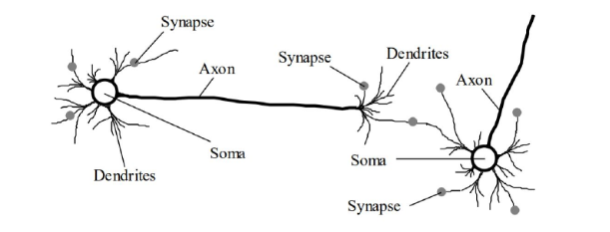

Fig 2.1 – Neuron of Brain

**Artificial Neuron:**

Like a brain neuron, neural networks consist of an artiﬁcial neuron. An artiﬁcial neuron (see Fig 2.2) consists of a weight to determine the strength of a connection, a linear function that needs to be computed and an activation function that computes the weighted sum of the linear function that is then compared to a threshold value.

It is also worthy to note that artiﬁcial neurons can be modiﬁed to contain diﬀerent linear

function algorithms such as Gradient Descent, Logistic Regression, etc and also diﬀerent activation functions such as ReLU (Rectiﬁed Linear Unit) or TanH functions which depends on the problem to solve.

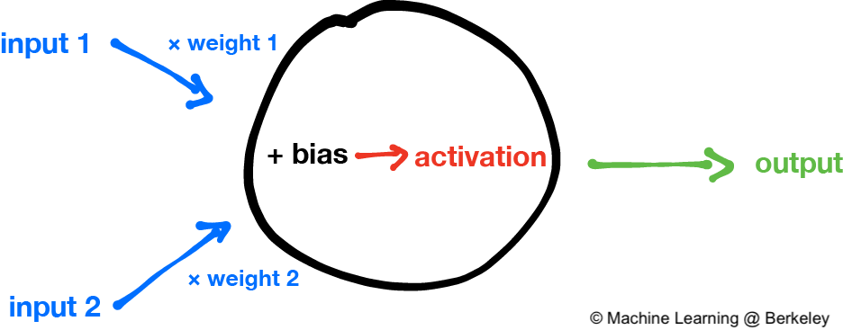

Fig 2.2 – Artificial Neuron

**Artificial Neural Network:**

ANNs are composed of multiple nodes, which imitate biological neurons of human brain. The neurons are connected by links and they interact with each other. The nodes can take input data and perform simple operations on the data.

An Artiﬁcial Neural Network (see Fig 2.3) is an interconnected architecture where there exists an input layer where input data is placed, a hidden layer(s) where artiﬁcial neurons are stacked on top of each other and an output layer where the prediction or classiﬁcation is made.

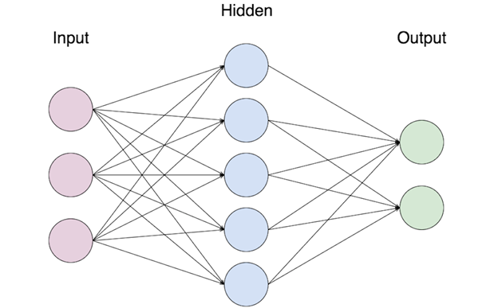

Fig 2.3 – Artificial Neural Network

**Forward Propagation:**

Forward propagation (see Fig 2.4) is technique in which data moves through from the corresponding input layer, hidden layers and output layer sequentially.

A hidden layer usually consists of a weight which is used in an optimization algorithm such as Gradient Descent, an activation function such as Sigmoid, TanH, LeakyReLU etc. and a Loss Function to calculate the loss or error of the function which we use to back propagate to adjust the weights

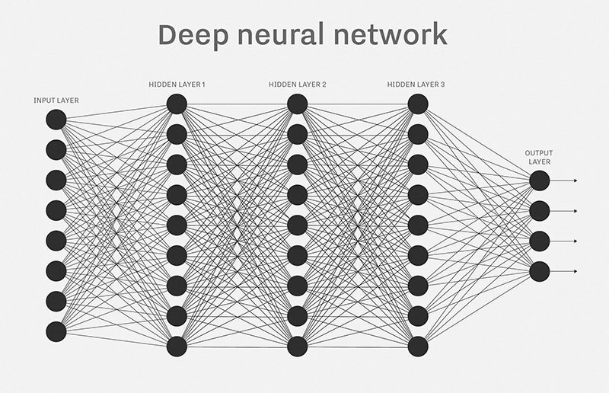

Fig 2.4 – Deep Neural Network

**Back Propagation:**

Back propagation is the opposite of Forward propagation as it feeds the network backwards. Back propagation is used to adjust the weight of the neural network after the errors have been computed by forward propagation algorithms.

**Activation Function:**

Activation functions (see Fig 2.5) are an important part of a neural network. They allow neural networks to create non-linear functions to solve problems. The 3 most used activation functions are Sigmoid, TanH and ReLU. Activation functions allow or stop neurons from ﬁring into the next layer by comparing it into the activation function thresholds.

Activation functions are used both in the forward and backward propagation where in the forward propagation an activation function is used to calculate the loss where the output of a function is compared to the real number and in backward propagation they are used to update the parameters of the neural network.

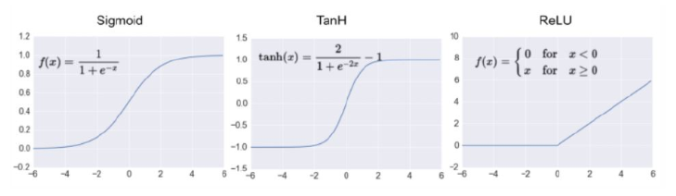

Fig 2.5 – Activation Functions

**2.2: Convolutional Neural Network**

Convolutional Neural Networks is all about using Deep Learning with Computer Vision. A good way to gain intuition about this is to think about a Neural Network Architecture and how it is applied to visual tasks i.e. Images and Video. Convolutional Neural Networks have allowed us to create Facial Recognition, Object Recognition (Fig 2.6), Self-Driving Cars and more.

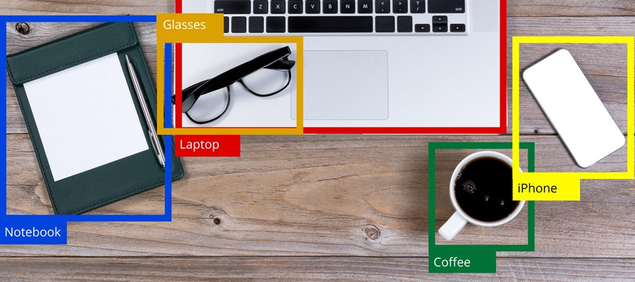

Fig 2.6 – Object Detection

**Architecture:**

Like a Neural Network, a typical Convolutional Neural Network (see Fig 2.7) consists of a multiple hidden layers called a Convolutional Layer where the linear function computes the strided convolutions over an image to extract features. It also consists of a pooling layer that computes another function such as Max Pool or Average Pool to reduce the size of the image in the neuron to speed up the computation. It does it by extracting the features of the neuron image and ignoring the rest, this makes the network more robust. There is also fully connected layer which is like a hidden layer in a neural network where the sum of the outputs of each layer are ﬂattened and where each value is an input to the next layer followed by an activation function and an output.

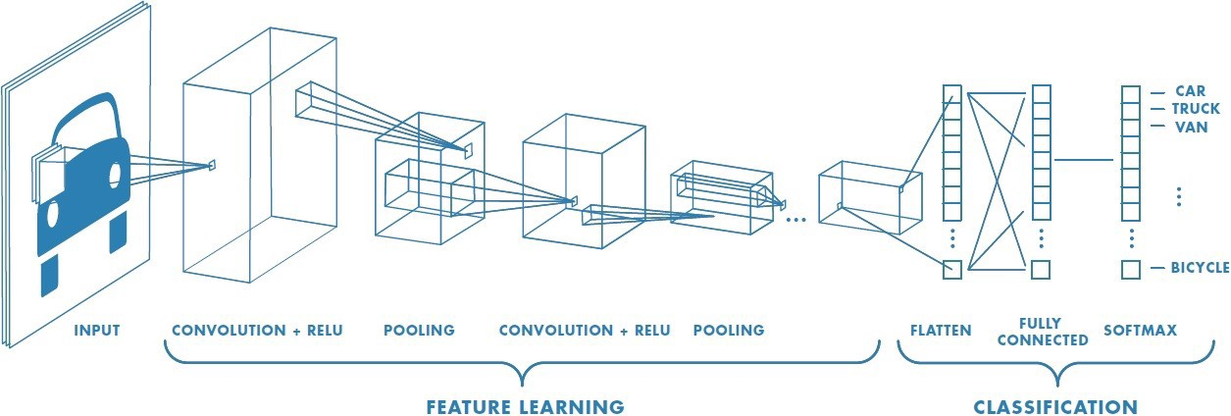

Fig 2.7 – CNN Architecture

**Convolution Layer:**

In a Convolutional Neural Network (Fig 2.8), the linear function that is used is called a convolutional layer. Each node in the hidden layer extracts diﬀerent features by using image processing feature detectors. For example, in the ﬁrst layer, the ﬁrst node may extract the horizontal edges of an image, the second node may extract vertical edges and etc. These features are extracted using a kernel.

The bottom is the original image and the top is the output of the convolutions. It is also worth noting that the output of the convolutions reduces the dimension of the original image.

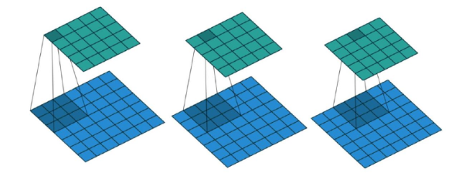

Fig 2.8 – Convolution Layer

**Stride:**

Stride is the number of pixels shifts over the input matrix. When the stride is 1 then we move the filters to 1 pixel at a time. When the stride is 2 (see Fig 2.9). we move the filters to 2 pixels at a time and so on. The below figure shows convolution working with a stride of 2.

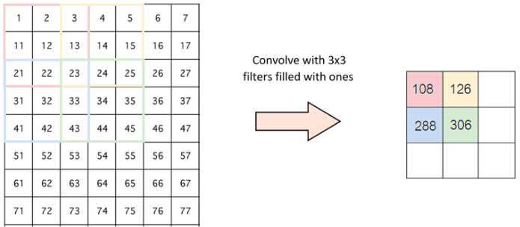

Fig 2.9 – Stride of 2

**Padding:**

Without padding (Fig 2.10) the edges of an image might be neglected in feature extraction. To ensure that no feature extraction of edges is missed, we apply padding to improve the efficieny of the model.

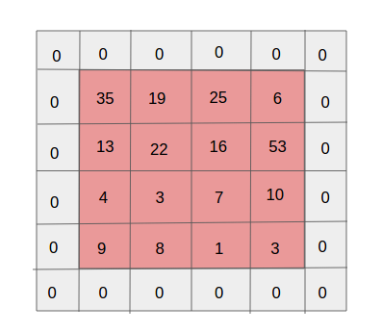

Fig 2.10 - Padding

**Pooling Layer:**

The pooling layer (Fig 2.11) happens to be computed after the convolutional layer. The reason why pooling is done is to further reduce the dimensions of the convolutional layer and just extract out the features to make the model more robust. There are two types of pooling done: max pooling and average pooling. Max pooling extracts out the highest pixel value out of a feature while average pooling calculates the average pixel value that has to be extracted.

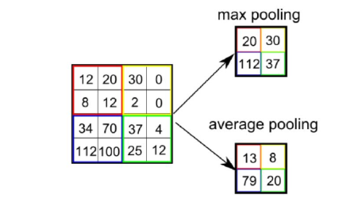

Fig 2.11 - Pooling

**Flattening:**

Flattening is an important step where pooled features map into a column. After the flattening step, we end up with a long vector of input data that you pass through the artificial neural network to have it processed further.

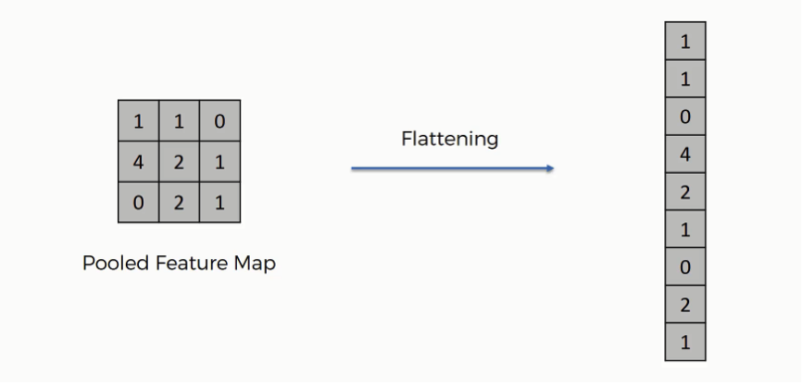

Fig 2.12 - Flattening

**2.3: TECHNOLOGIES USED**

Python:

Python is a high level interpreted language used for general purpose programming. It is widely used for scientiﬁc computing and can be used for a wide variety of general tasks from data mining to software development. Python is the main language used for this project.

Anaconda:

Anaconda is a popular data science platform where you can create data science projects and machine

learning. Libraries such as Numpy, Pandas, Matplotlib, Tensorﬂow and etc come with Anaconda and

IDE’s such as Jupyter Notebook, Spyder and etc.

Numpy:

Numpy is a library in Python that allows for eﬃcient numerical computing in Python. This library is highly optimized to do mathematical tasks. In the project workﬂow Numpy is heavily used in data pre-processing and preparation One of the main features about Numpy is it’s highly eﬃcient n-dimensional array (ndarray). Compared to a list in Python a Numpy array can be n-dimensions and has more features associated with the ndarray. Numpy can also perform more eﬃcient mathematical operations compared to the math library in Python.

Pandas:

Pandas is also a library in Python, like numpy is also used for data pre-processing and preparation. One of the main features about pandas is the DataFrame and Series data structure. These data structures are optimized and contain fancy indexing that allow a variety of features such as reshaping, slicing, merging, joining and etc to be available.

Matplotlib:

Matplotlib is a Python plotting library that allows programmers to create a wide variety of graphs and

visualizations with ease of use. The great feature about Matplotlib is that it integrates very well with

Jupyter Notebook and creating visualizations is simpliﬁed. Matplotlib also works very well with pandas and Numpy.

OpenCV:

OpenCV (Open Source Computer Vision) is a well-established computer vision library which is written in C/C++ and has been abstracted to interface with C++, Python and Java. This is a powerful tool when working with images and has a myriad of tools regarding image data manipulation, feature extraction and etc.

Tensorflow:

Tensorﬂow is an open source deep learning library by Google. It was originally developed by Google’s engineers who were working on Google Brain and has been used for research on machine learning and deep learning. Tensorﬂow at its core is about computations of multidimensional arrays called tensors but what makes Tensorﬂow great is its ability to be ﬂexible to deploy computations on diﬀerent devices such as CPU’s and GPU’s.

Keras:

Keras is also a Deep Learning Framework that abstracts much of the code in the other Frameworks like Tensorﬂow and Theano. Compared to the other frameworks Keras is more minimalist.

Jupyter Notebook IDE:

The Anaconda distribution comes with a variety of software that includes Jupyter Notebooks for scientiﬁc computing. Jupyter Notebooks is an open source software IDE that allows developers to create and share documents that contain live code and more.

Spyder:

Spyder, the Scientific Python Development Environment, is a free integrated development environment (IDE) that is included with Anaconda. It includes editing, interactive testing, debugging and introspection features.

**CHAPTER 3: METHODOLOGY**

**3.1: DATA UNDERSTANDING**

This phase is about collecting the data, gaining familiarity and ultimately understanding the data. This data deals with DICOM (Digital Imaging and Communications in Medicine) files. DICOM is the international standard to transmit, store, retrieve, print, process and display medical imaging information. DICOM is used for communication and management of medical imaging information and related data. It is most commonly used for storing and transmitting medical images. They are used for creating visual representations of the interior of a body for clinical analysis. This process is done by analysing DICOM files which visually represent the working of organs or tissues present inside the human body.

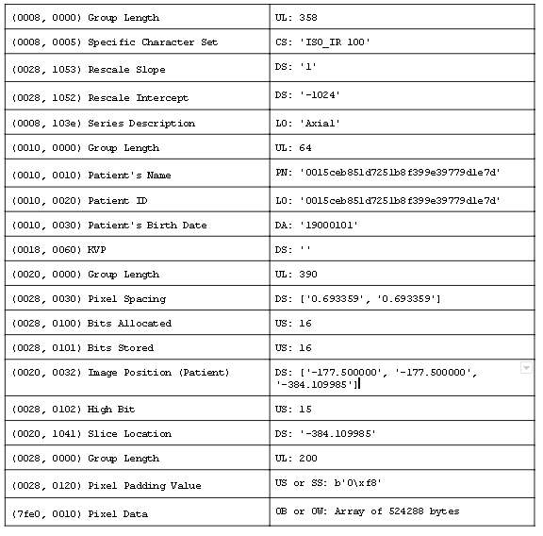

Table 3.1 – Metadata of DICOM file

DICOM groups information into data sets (see Table 3.1). For example, a file of chest x-ray image may contain the patient ID within the file, so that the image can never be separated from this information by mistake. This is similar to the way that image formats such as JPEG can also have embedded tags to identify and otherwise describe the image.

A DICOM data object consists of a number of attributes, including items such as name, ID, etc. and also special attribute containing the image pixel data (i.e. logically, the main object has no ‘header’ as such, being merely a list of attributes, including the pixel data). A single DICOM object can have only one attribute may contain multiple frames, allowing storage of loops or other multi-frame data.

**3.2: DATA PREPARATION**

**3.2.1: Averaging Method**

The downloaded data consists of many 2D-slices (DICOM files), which, when combined, produce a 3-dimensional rendering of the scans. In this case, that’s the chest cavity of the patient. We’ve got scans about 1368 patients, and then we’ve got another file that contains the labels for this data. There are numerous ways that we could go about creating a classifier. Being a realistic data science problem, we actually don't really know what the best path is going to be. Thus, we have to begin by simply trying things and seeing what happens.

There exists a Python package called ‘pydicom’ for reading DICOM files. Once read, we get the list of patients by their IDs, and their associated labels in a dataframe (see Table 3.2). Now, we can begin to iterate through the patients and gather their respective image data. We're almost certainly going to need to do some pre-processing of this data.

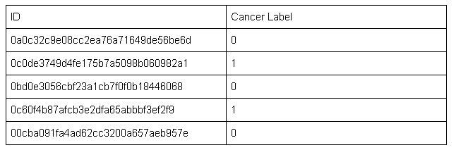

Table 3.2 – Dataframe of labels

Each patient consists around 200 scans and the resolution is about 512 x 512. Below is the sample data consisting the resolution and no. of scans of 10 patients.

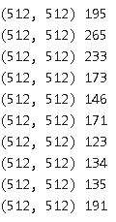

This means our 3D rendering is a 200 x 512 x 512 which is huge. So, we are going to absolutely need to resize the data. So, a DICOM file has many attributes but the ‘pixel_array’ attribute consists of the image data. A sample CT scan as shown in the (Fig 3.1).

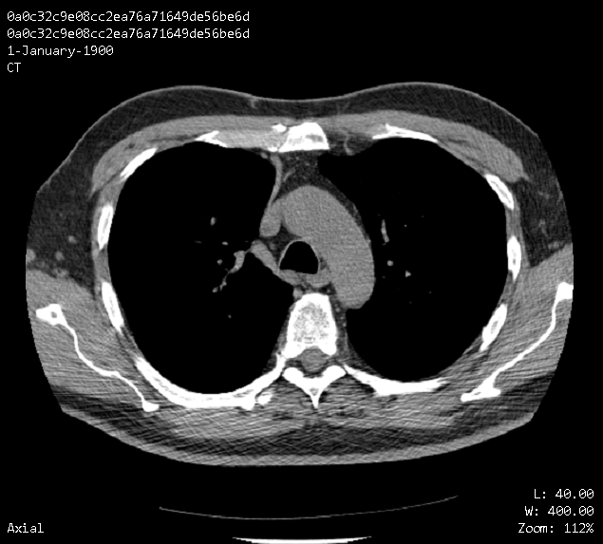

Fig 3.1 – CT Scan

The number of slices for each patient is way too big for a convolutional neural network(CNN) to handle without some serious computing power. So, we need to down sample this data. We resize our images from 512 x 512 to 100 x 100 which is also huge data but a GPU can handle this data. The resize is done using the ‘openCV’ tool.

Having around 200 scans for each patient is troublesome, so, we reduce it to 20 scans instead. To do this we will take a current list of scans and chunk it into list of lists of scans. Once the chunks of these scans are ready, we can just average them together. Due to the uneven number of slices in each patient chunking and averaging these slices would not give a constant output of 20 slices. If the slices count exceeds 20 average the excess scans with the 20th slice. If the slice count precedes 20 repeat the last slice until 20th.

Below mentioned is the data consisting the actual no. of scans and the averaged no. of scans of 5 patients.



Now we’ve got pre-processed, normalized data which is ready to be fed through a neural network(CNN).

**3.2.2: Image Enhancement and Lung Segmentation**

This is another method adopted to observe the accuracy differences obtained in both the methods. In this method we are going to apply image enhancement or segmentation techniques for the original data.

**Gabor Filter:**

Gabor filters are orientation-sensitive filters, used for edge and texture analysis. Gabor filters are thought to be a good model of how humans distinguish texture, and are therefore a useful model to use when designing algorithms to recognize texture.  Basically, it means that Gabor filter is mathematically structured in such a way that it can take care of different shapes, sizes and smoothness levels in the image.

The pre-processing steps followed are:

**Loading the DICOM files:** These files contain a lot of metadata but the requirement for a neural network is the pixel data of an image which can be derived from a ‘pixel_array’ attribute.

**Apply Gabor Filter:** On the image data derived from the DICOM files, Gabor Filter has been applied as an image enhancement technique.

**Hounsfield Units(HU):** The unit of measurementin CT scans is the Hounsfield Unit (see Table 3.3)**,** which is a measure of radio density**.** In this step, we convert the pixel values of the image to Hounsfield units and these unit values correspond to specific tissues.

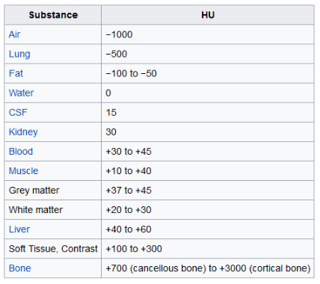

Table 3.3 – Hounsfield (HU) Table

[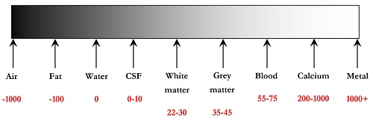](http://www.southsudanmedicaljournal.com/archive/august-2016/how-to-interpret-an-unenhanced-ct-brain-scan.-part-1-basic-principles-of-computed-tomography-and-relevant-neuroanatomy.html)

Fig 3.2 – Hounsfield Intensity Scale

By default, the slices do not return values in this unit. The pixel values of the image can be converted into HU units by multiplying with the rescale slope and adding the rescale intercept. (which are stored in the meta data of the scans). The Hounsfield intensity scale is shown in the (Fig 3.2)

Below is a graph between Hounsfield units and its Frequency.

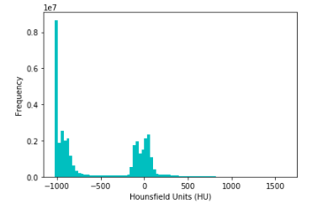

Fig 3.3 – Histogram

**Resampling:** A scan may havepixel spacing of [2.5, 0.5, 0.5], which means that the distance between slices is 2.5 millimetres. For a different scan this maybe [1.5, 0.75, 0.75], this can be problematic for automatic analysis. A common method of dealing with this is resampling the full dataset to a certain isotropic resolution. If we choose to resample everything to 1mm x 1mm x 1mm pixels we can use 3D convnets without worrying about slice thickness invariance.

**3D plotting:** For visualization it is useful to be able to show a 3D image of the scan. We used matplotlib to visualize the 3D image.

**3D plotting of Bone Structure:**

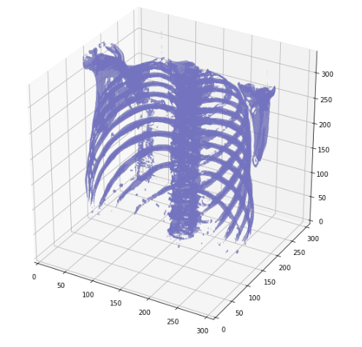

Fig 3.4 – 3D plotting of Bone Structure

**Lung Segmentation:** In order to reduce the problem space, we can segment the lungs and usually some tissue around it. Our values currently range from -1024 to 2000. Anything above 400 is not interesting to us as these are simply bones with different radio density. To remove unwanted tissues, we set a threshold limit. In this case - 400 HU to + 400 HU is a good threshold limit and the lower and higher values can be neglected.

**3D plotting of Lungs:**

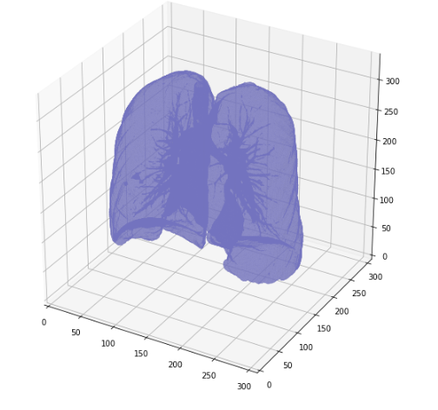

Fig 3.5 – 3D plotting of Lungs

**3D plotting of segmented Lungs:**

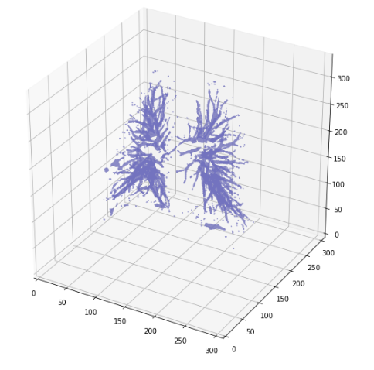

Fig 3.6 – 3D plotting of segmented Lungs

With these steps our images are ready for consumption by CNN.

**CHAPTER 4: RESULT ANALYSIS**

4.1: Training Phase

In this experiment, Nuronics Labs has provided a total of 1368 patient’s data, where we used the data generated from 1094 patients scans as the train data. The remaining 274 patient’s scans are used as test data. This experiment was conducted on a desktop equipped with Intel i7 processor, 20GB memory and a GeForce GTX 1050 GPU.

4.2: Results

In the basic model created, to check the working nature of the model, we trained it with a data of 100 patients (training data – 80 patients, testing data – 20 patients) and the results are as follows:

Training Accuracy – 48.6%

Testing Accuracy – 49.8%

On the final working model, with the averaged method, we trained it with complete data and the results are as follows:

Training Accuracy – 71.2%

Testing Accuracy – 72.7%

On the final working model, with the image enhancement and lung segmentation method, we acquired better results than the averaged method and the results are as follows:

Training Accuracy – 76.2%

Testing Accuracy – 76.8%

**Accuracy Table:**

|  |  |  |  |  |
| --- | --- | --- | --- | --- |
|  | Training Data | Testing Data | Training Accuracy | Testing Accuracy |
| Basic Model | 80 | 20 | 48.6 | 49.8 |
| Avg Method | 1094 | 274 | 71.2 | 72.7 |
| Lung Segmentation Method | 1094 | 274 | 76.2 | 76.8 |

Table - 4.1

The data is in terms of no of patients.

The accuracy is in terms of percentage (%).

**CHAPTER 5: CONCLUSION AND FUTURE SCOPE**

**5.1: Conclusion**

Doctor’s working in this field are prone to observer fatigue from viewing so many CT scan images. Due to this, the risk of errors to be made by doctors while analysing these scans rise. For example, for every 200 – 300 scans only 2 – 3 scans would show cancer nodules depending on the stage of the patient. Therefore, by the usage of Deep Learning techniques in this field could gradually decrease the errors made.

In this study, various optimization algorithms have been evaluated to detect the tumor. Medical images often need pre-processing before being subjected to statistical analysis. We used CNN based procedures to detect nodules in CT scans of Lung. We study and compare the two methodologies we adopted, one with the averaging technique, and the other with image enhancement and lung segmentation techniques. We adopted Gabor filter as an image enhancing technique to enhance the edges of an image for better feature extraction. And with additional lung segmentation technique the results were further improved. With this filter, we got better results than the averaging method.

**5.2: Future Scopes**

The further enhancement of the proposed methods can be focused on the following ideas for better performance and efficient images.

* Removal of noise from the images can better the performance of a model.
* Better learning techniques can be used to increase the performance and quality of the method.
* Improving the quality of CT scans.
* An improved segmentation technique on enhanced CT scans could deliver better results.
* By the application of predefined Neural Networks on the model, we are likely to observe an improvement in the accuracy. The implementation of pre-nets on the model is termed as “Transfer Learning”.

**REFERENCES**

*Journal / Conference Papers*

[1] Mokhled S. AL-TARAWNEH, “Lung Cancer Detection Using Image Processing Techniques”, Leonardo Electronic Journal of Practices and Technologies, Issue 20, Jan–June 2012, p.147-158

[2] S Vishukumar K Patela, “Implementation of Medical Image Enhancement Using Gabor Filter”, International Journal of Current Engineering and Technology, 2012

[3] S. Sasikala, M. Bharathi, B. R. Sowmiya, “Lung Cancer Detection and Classification Using Deep CNN”, Lung Cancer Detection and Classification Using Deep CNN, Volume-8 Issue-2S December, 2018

*Reference / Hand Books*

[1] <https://towardsdatascience.com/a-comprehensive-guide-to-convolutional-neural-networks/>

[2] <https://adventuresinmachinelearning.com/neural-networks-tutorial/>

[3] <https://prateekvjoshi.com/2014/04/26/understanding-gabor-filters/>

PROJECT DETAILS

|  |  |  |  |  |  |
| --- | --- | --- | --- | --- | --- |
| *Student Details* | | | | | |
| **Student Name** | **Nutakki Serath Chandra** | | | | |
| Register Number | 159108080 | | Section / Roll No | | B / 24 |
| Email Address | serathchandra777@gmail.com | | Phone No (M) | | +91 8897876944 |
|  | | | | | |
| *Project Details* | | | | | |
| **Project Title** | **Lung Cancer Detection** | | | | |
| Project Duration | 2 months | | Date of reporting | | 25th May, 2019 |
|  |  | | | | |
| *Organization Details* | | | | | |
| **Organization Name** | **Nuronics Labs Private Limited** | | | | |
| Full postal address with pin code | Plot185, Road No. 74, Film Nagar, Hyderabad, Telangana – 500033 | | | | |
| Website address | [www.nuronics.com](http://www.nuronics.com) | | | | |
|  |  | | | | |
| *Supervisor Details* | | | | | |
| **Supervisor Name** | **P. Mythilisharan** | | | | |
| Designation | Software Architect | | | | |
| Full contact address with pin code |  | | | | |
| Email address | [mythili@nuronics.com](mailto:mythili@nuronics.com) | | Phone No (M) | | +91 9493135757 |
|  |  | | | | |
| *Internal Guide Details* | | | | | |
| **Faculty Name** | **Mr. Khamesh Kumar** | | | | |
| Full contact address with pin code | Manipal University Jaipur, Dehmi Kalan, Jaipur, Rajasthan – 303007 | | | | |
| Email address | Khamesh.kumar@jaipur.manipal.edu | Phone No (M) | | +91 9940540824 | |